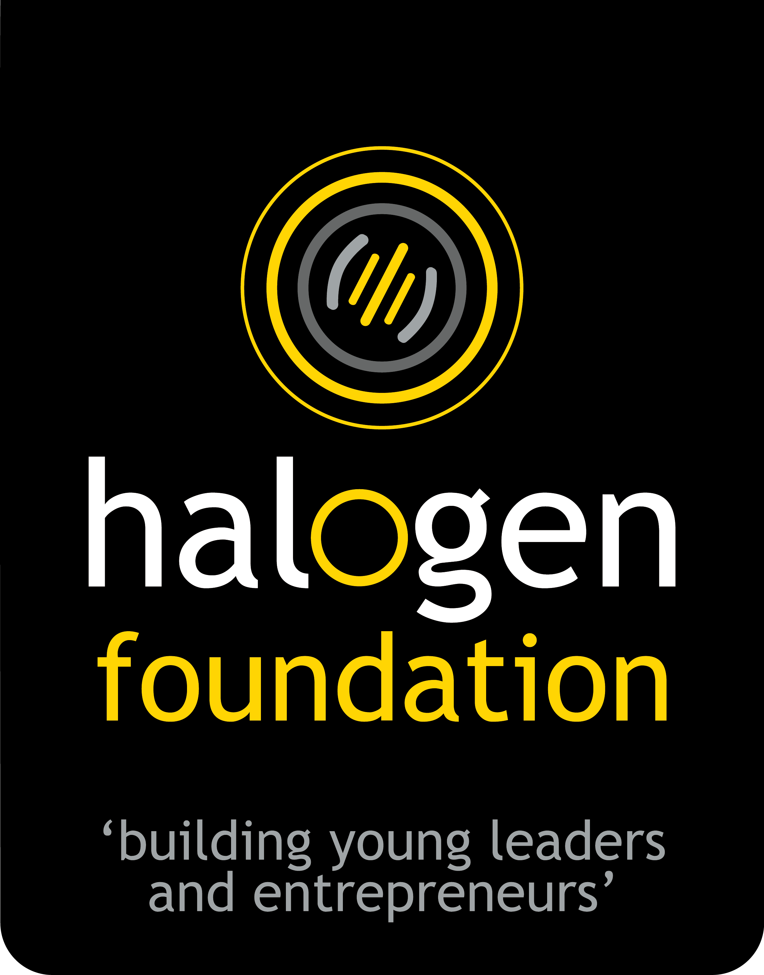
HALOGEN FOUNDATION SINGAPORE

NATIONAL YOUNG LEADER AWARD 2019

APPLICATION FORM

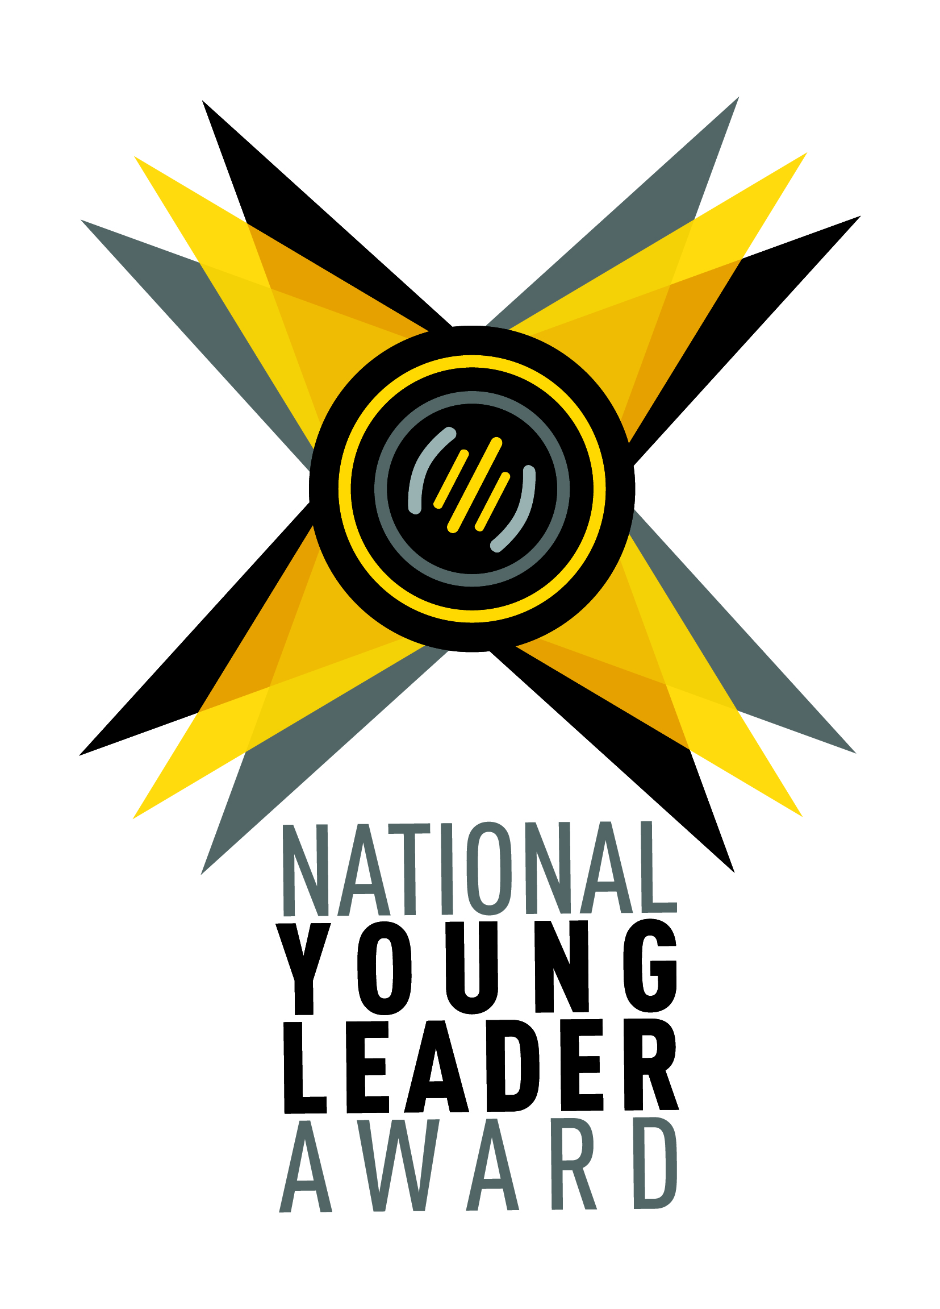

“Halogen wants to celebrate young people whom we believe have the potential to make a significant positive difference to our world.
Young leaders who are involved, engaged, and have conviction in the things they do.
Our future generation, who through their actions, demonstrate to us that they can make a difference no matter how young they are.”

Full Name:
(As shown in NRIC)
School / Organisation you are representing:
Age:
Nationality: | Singaporean Others:
Gender: | Female Male
Contact Email:
Handphone Number:

- Tell us about your involvements inside and outside of school.
(Maximum of 2000 characters, about 300 words)

- Share an incident that changed your perspective and explain why.
(Maximum of 2000 characters, about 300 words)

- If selected as a National Young Leader Award winner, what do you hope to achieve? (Maximum of 2000 characters, about 300 words)

- Make a compulsory 1-minute video answering "What is leadership to you?".
  - You will be scored by the content of your video. Not by the production value. Ensure that the audio is clearly audible.
  - Direct Message (DM) the video via Instagram to @halogensg.
  - Fill in your Instagram Username below for our matching purposes. (e.g @halogensg)
Instagram Username: @

- Do you want to refer someone else for this award?
Yes | No
If Yes:
Name of Referral:
Email:

Thank you for completing the National Young Leader Award application form.

1. Would you be able to attend the Leadership Masterclass on Saturday 20 April?
Attendance is free and highly encouraged for the Award process. YES NO

Hear from an expert panel what should really matter to leaders and to those whose lives we
influence. Meet like-minded young leaders and broaden your perspective of leadership.

2. How did you find out about the award?

Teacher | Facebook
Friend | Instagram
Halogen Foundation Website | Internet search for opportunities
Email | Others:

3. We Respect and Keep Your Data Safe
By supplying your personal details, you give consent to receive updates on future programmes, events and marketing materials by Halogen Foundation Singapore.
Please check box and indicate if you do not allow Halogen Foundation Singapore to use your personal information for the following purposes related to:
(Choose as many as you like)
Future Programmes Events Marketing Material None of the above

------------------ End of Application Form ------------------

To submit, please ensure that all fields have been completed.
Save the file in (.docx) format. Rename the file with your name in the front.

EITHER email the completed form to: award@halogen.sg

OR print out and mail it to: National Young Leader Award Nomination
Halogen Foundation Singapore
336 Smith Street #07-303
New Bridge Centre Singapore 050336

