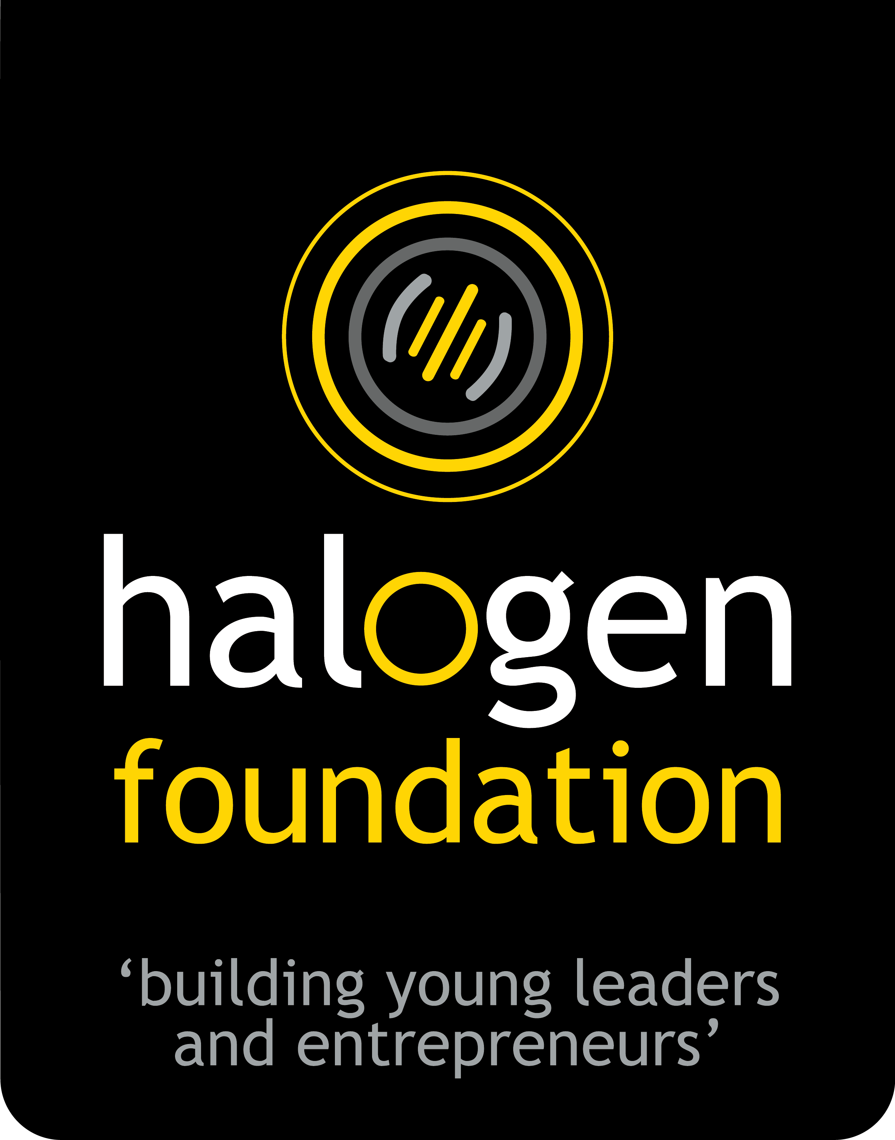
HALOGEN FOUNDATION SINGAPORE

NATIONAL YOUNG LEADER AWARD 2020

APPLICATION FORM

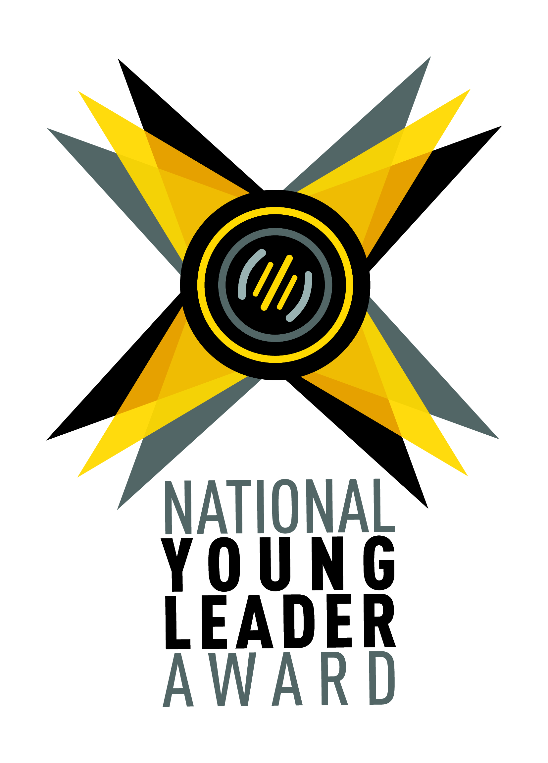

“Halogen wants to celebrate young people whom we believe have the potential to make a significant positive difference to our world.
Young leaders who are involved, engaged, and have conviction in the things they do.
Our future generation, who through their actions, demonstrate to us that they can make a difference no matter how young they are.”

Full Name:
(As shown in NRIC)
School / Organisation you are representing:
Age:
Nationality: | Singaporean Others:
Gender: | Female Male
Contact Email:
Handphone Number:

- Tell us about your involvements inside and outside of school.
(Maximum of 2000 characters, about 300 words)

- Share an incident that changed your perspective and explain why.
(Maximum of 2000 characters, about 300 words)

- If selected as a National Young Leader Award winner, what do you hope to achieve? (Maximum of 2000 characters, about 300 words)

- Make a compulsory 1-minute video answering "What is leadership to you?".
  - You will be scored by the content of your video. Not by the production value. Ensure that the audio is clearly audible.
To Submit
- Rename the video file to: <FIRST NAME><space> <LAST NAME>_<8-DIGITS HP NUMBER>
E.g sample file name: JOHN TAN_81234567.mp4. This file name will be used for matching and identification.
- Rename this application form with the same file name. Submit in word .doc format. (E.g JOHN TAN_81234567.doc)
- Upload the both video and application form via the link <bit.ly/nyla2020submission>.

------------------ End of Application Form ------------------

Thank you for completing the National Young Leader Award application form.

1. How did you find out about the award?

Teacher | Facebook
Friend | Instagram
Halogen Foundation Website | Internet search for opportunities
Email | Others:

2. Would you be able to attend the Leadership Masterclass in April 2020?
Hear from an expert panel what should really matter to leaders and to those whose lives we influence. Meet like-minded young leaders and broaden your perspective of leadership.
Attendance is free and highly encouraged for the Award process. YES NO

3. We respect and keep your data safe.
By supplying your personal details, you give consent to receive updates on future programmes, events and marketing materials by Halogen Foundation Singapore.
Please check box and indicate if you do not allow Halogen Foundation Singapore to use your personal information for the following purposes related to:
(Choose as many as you like)
Future Programmes Events Marketing Material None of the above

4. Would you like to refer a friend / peer to apply for this award?
(They must be aged 15 to 19 as of December 2020 to be eligible for the award.)

If yes, please fill in their contact below so we can contact them:

Name of your friend / peer:
School or organisation they are from:
Contact Number:
Email:

