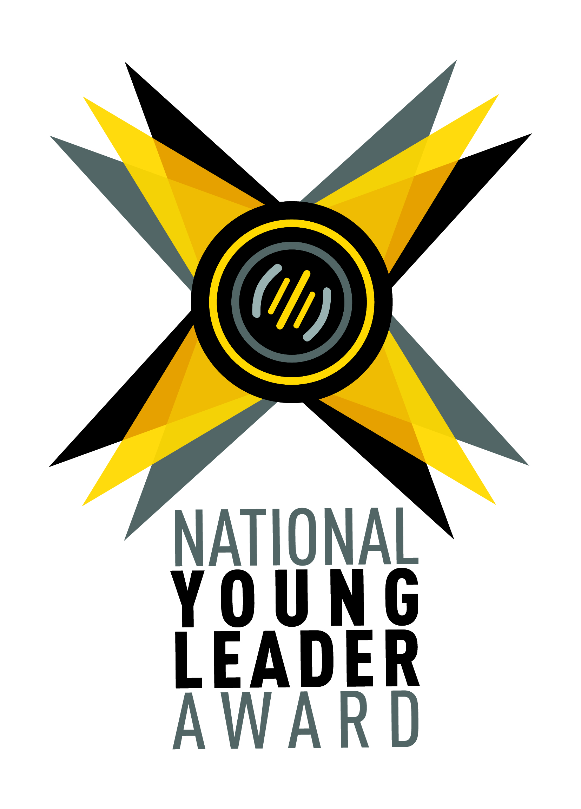
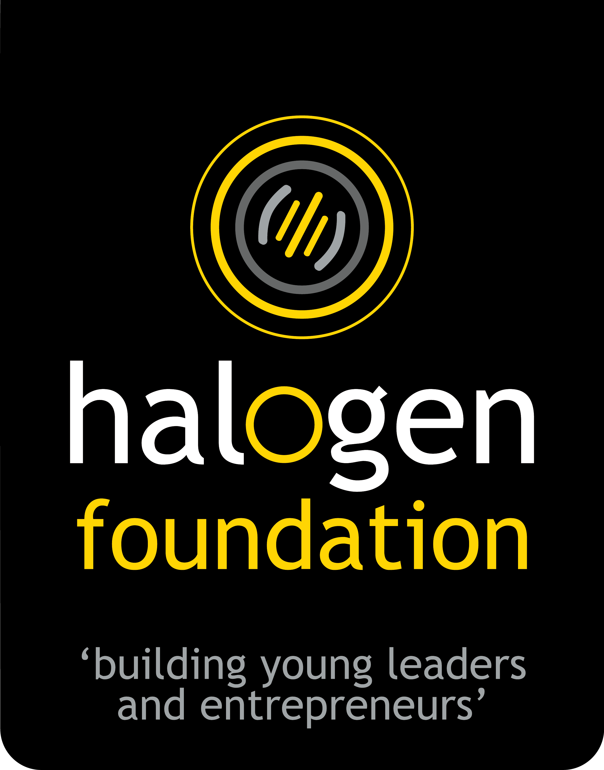

NATIONAL YOUNG LEADER AWARD 2021

APPLICATION FORM

Only fill this application form by TYPING ONLY. Do not fill this application form by handwriting.

If you would like to fill in an online version, the online application form can be found at: halogen.sg/nyla
APPLICANT CONTACT INFORMATION
Full Name (As shown in your NRIC):
School / Organisation you are representing:
Age (Only youth between the ages 15 to 19 are eligible for this award)
Nationality:
Singaporean ✅ If not Singaporean, please indicate your Nationality here:
Gender (Delete option accordingly)
Female / Male
Contact Email
8-digit Handphone Number:

All information collected will be kept strictly private & confidential, and used in accordance with current PDPA laws. You may view our data protection policy and commitment at https://halogen.sg/pdo

This Application Form has 4 questions in total; made of 2 parts (Part A and Part B).
- Part A: 1-minute Video Submission
- Part B: 3 Essay Questions

PART A: Make a compulsory 1-minute video answering "What is leadership to you?"

1. You will be scored by the content of your video. Not by the production value. Ensure that the audio is clearly audible.
2. All videos should be in mp4 format and should not exceed 1-minute.

3. For identification purposes, please rename your video file with your 8-Digit Handphone Number.
Sample file name: 81234567.mp4
4. Instructions on how to submit the video can be found on the last page of the application form.

PART B: Choose only 3 out of the 5 essay questions to answer.
Do not answer all five questions. Only select THREE questions to answer. Each question allows a maximum of 3000 characters (about 500 words).

i. Tell us about your involvements inside and outside of school.

ii. Tell us about your interest area and how you have rallied others to that interest.

iii. Tell us about an issue or passion area you feel strongly about.
Why and what have you done for that cause?

iv. Share about an incident where you were able to lead your team to overcome a challenge.

v. Tell us about an incident when your core values were challenged.
What values were they, how were they challenged, and how did you resolve the incident?

You have come to the end of the application form. Please answer all 4 survey questions below.

1. How did you find out about the award?
(Select as many as applicable by copying this icon ✅ to the boxes below)

 | Teacher |  | Facebook / Instagram
 | Friend |  | Internet search for opportunities
 | Halogen Foundation Website |  | Leadership Masterclass
 | Nomination Email from Halogen Foundation |  | Others:

2. Would you be able to attend the virtual Leadership Masterclass in April 2021?
Hear from an expert panel what should really matter to leaders and to those whose lives we influence. Meet like-minded young leaders and broaden your perspective of leadership.
Attendance is free and highly encouraged for the Award process.
✅ | YES |  | NO

3. We respect and keep your data safe.
By supplying your personal details, you give consent to receive updates on future programmes, events and marketing materials by Halogen Foundation Singapore.
Please check box and indicate if you do not allow Halogen Foundation Singapore to use your personal information for the following purposes related to:
(Select as many as applicable by copying this icon ✅ to the boxes below)

 | Future Programmes |  | Events |  | Marketing Material |  | None of the above

4. Would you like to refer a friend / peer to apply for this award as well?
We will help reach out to them upon your recommendation.
✅ | YES |  | NO

If Yes, please let us know their contact details and we'll reach out to them to share the opportunity.

Full Name of Nominee:

Their Email Address:

Their Handphone Number:

By submitting this application form, I confirm that the information stated above is true, complete and accurate to the best of my knowledge and belief.

Your Signature or Initials

------------------ End of Application Form ------------------

Thank you for completing the National Young Leader Award application form.

To submit this application form and video:
- Please ensure that all fields in the application form have been completed and your 1-minute video has been recorded.
- Save this application form to your computer as (.doc or .docx) format and rename the file name with your 8-digit Handphone number accordingly. E.g 81234567.docx
- Save your 1-minute video to your computer as (.mp4) format and rename the file name with your 8-digit Handphone number. E.g 81234567.mp4
- Click on this OneDrive link (bit.ly/sub2021nyla) to upload the application form file and the video file. (Sample screenshots are appended below for reference.)
  - Click “Select files”
  - A window will pop up for you to select your application form. Locate your filled application form file and click “Open”.
  - Click “+ Add more files” to upload your video file.
  - Another window will pop up. Locate your video file and click “Open”.
  - Fill in the required fields for “First name” and “Last name”
  - Click “Upload” to finish the submission.
  - If your submission is successful, you will be redirected to another page with a tick in a green circle.

------------------------------------------------------------------------
If you encounter issues with the submission process or have any questions with regards to the Award,
please email us at award@halogen.sg

Appendix:

Sample Screenshots of how to upload the application form and video file:
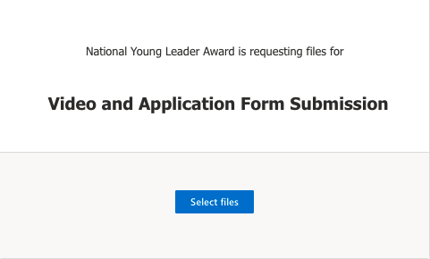 | - Click “Select files”
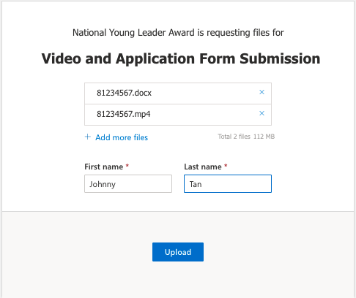 | - A window will pop up for you to select your application form. Locate your filled application form file and click “Open”.  - Click “+ Add more files” to upload your video file.  - Another window will pop up. Locate your video file and click “Open”.  - Fill in the required fields for “First name” and “Last name”  - Click “Upload” to finish the submission.
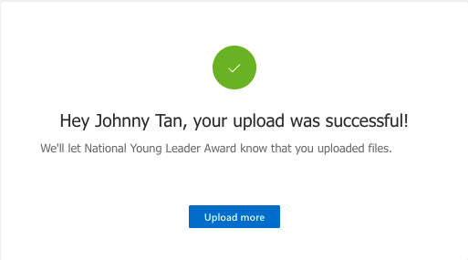 | - Click “Upload” to finish the submission.  - If your submission is successful, you will be redirected to another page with a tick in a green circle.

